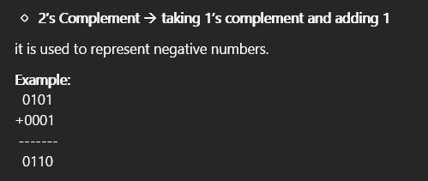
🔹 1’s Complement flipping all bits (0 → 1, 1 → 0)
Example:
1010
--------
0101

A | B | A & B | A | B | A ^ B | ~A | ~B
0 | 0 | 0 | 0 | 0 | 1 | 1
0 | 1 | 0 | 1 | 1 | 1 | 0
1 | 0 | 0 | 1 | 1 | 0 | 1
1 | 1 | 1 | 1 | 0 | 0 | 0

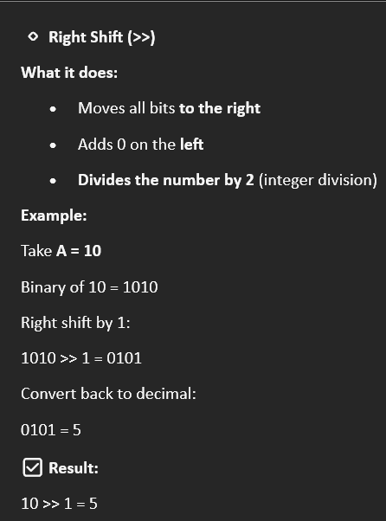
🔹 Left Shift (<<)
What it does:
- Moves all bits to the left
- Adds 0 on the right
- Multiplies the number by 2 (for 1 shift)
Example:
Take
A = 5
Binary of 5 = 0101
Left shift by 1:
0101 << 1 = 1010
Convert back to decimal:
1010 = 10
✅ Result:
5 << 1 = 10

🧠Memory Trick
- Shift left → multiply
- Shift right → divide
- Number of shifts = power of 2

Rule (IMPORTANT)
- Bit 31 (leftmost bit) = Sign bit
  - 0 → Positive
  - 1 → Negative
- Uses Two’s Complement for negative numbers

🔹 Number Representation (Simple)
Example 1: n = +13
- Sign bit = 0 (positive number)
- Binary of 13 = 1101
- 8-bit representation: 00001101
👉 MSB (leftmost bit) = 0 → positive

Example 2: n = −13 (Two’s Complement)
Step 1: Write +13 in binary : 00001101
Step 2: Take 1’s complement: 11110010
Step 3: Add 1 (2’s complement)
11110010
+ 1
---------------
11110011

✅ This is −13
👉 MSB = 1 → negative number

To perform any operation keep this in mind

